

THE NEW GENERATION IN TRADITIONAL MUSICS

AN ARTISTIC AND PEDAGOGICAL
PROJECT OF
THE ATELIERS D’ETHNOMUSICOLOGIE
FOR THEIR 30TH ANNIVERSARY

Contact :

Mrs Astrid Stierlin - Artistic Director of this project
Responsable for the educational activities

Ateliers d'ethnomusicologie
10, rue de Montbrillant
1201 Genève

Phone : 00 41 22 919 04 94
Fax : 00 41 22 919 04 95

http://www.adem.ch
Email : a.stierlin@mail-box.ch
THE ATELIERS D’ETHNOMUSICOLOGIE
Founded in Geneva in 1983, the Ateliers d’ethnomusicologie (ADEM) is a cultural association dedicated to world music and dance. Throughout the year, the Ateliers offers concerts and festivals, lessons and courses, as well as activities for young people. The Ateliers also produces books and CDs and supports migrant musicians who live in the region.
The Ateliers d’ethnomusicologie has existed since 1983, without taking into account the long period of development leading up to its formation. The existence of the Ateliers d’ethnomusicologie can be considered significant in two respects: on the one hand, it underlines a new openness towards “world cultures” and “other” cultures, which is perhaps one of the striking characteristics of post-colonial awareness at the end of the 20th Century and beginning of the 21st; on the other hand the association expresses in its own manner the “spirit of Geneva”, of which its inhabitants pride themselves on, a spirit that could be characterised by a certain type of tolerance, humanism and intercultural appreciation.
So as to celebrate the ADEM's 30th anniversary, we will be hosting a new generation of traditional musicians who were not even born at the time our association formed ! Even though these artists were all born after 1983, they are proof of the vivacity of traditional cultures in their respective countries of origin.

We would like to give the floor to these artists who are not the product of schools or institutes but are the receptacles for systems of oral transmission within the context of musical families. This manner of transmitting knowledge is in keeping with the way it has been practised over the course of the centuries up until today.

Featured in regular ADEM collaborations, the Coulibaly family of Bobo-Dioulasso and the Mishra family of Benares have dedicated themselves to music for several generations and have several points in common: they live in areas far from the influence of governmental cultural politics and they live in culturally fertile cities, which act as important cultural crossroads. The artist’s private initiative and personal engagement is thus a determining factor in the transmission of traditional knowledge.

These two families of artists have contributed a lot to the ADEM's activities, and their reputations have thus extended beyond that of their countries. Following the momentum created by these exchanges, they have continued on with these sorts of activities in their own countries, aware of the importance of the legacy that they hold.

We are also aware of the importance of supporting the transmission of traditional culture in that culture's country of origin. By inviting artists who come from these artistic centres to Geneva, we have contributed to preservation of their art and to the recognition of their work in their country of origin - a fundamental condition in allowing them to ensure the longevity of their art.

NEW BENARES
THE NEW GENERATION OF KABIR CHAURA

Fro 30 April to 16 May 2014 in Switzerland

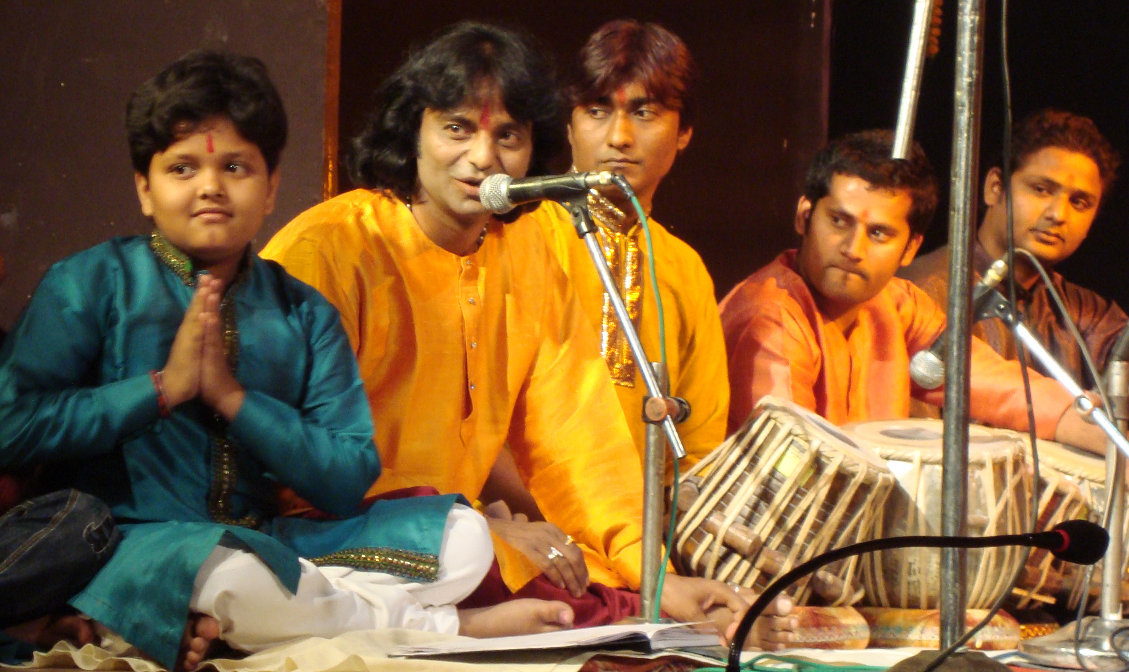

Musicians
Ravi S. Mishra : Pakavaj, bol paran
Ram Kumar Mishra, Aditya Shankar Mishra: Tablas
Kanchen Mishra : Vocal and harmonium
Sandeep Mishra : Sarangi

Dance
Saurav and Gaurav Mishra
Abhijeet Mishra
Fanny Meera Marquet
Priscilla Gauri Brulhart
Vidéos sur Youtube : http://www.youtube.com/watch?v=MncFvJcO-nk
http:// www.youtube.com/watch?v=X3rFjbJE8uQ

Webdoc :
http://growingintomusic.co.uk/north-indian-art-music/films-of-growing-into-north.html

The holy city of Benares (also called Kashi or Varanasi) is a place of great importance in Hindu spirituality and is the centre of convergence for countless pilgrims, who carry out their ablutions in the waters of the Ganges. But Benares is also an important artistic hub, notably in relation to music and dance.

Over the last few centuries, the ensemble of learned musical and dance traditions from North India has been transmitted through artistic lineages or schools (gharana), each of which has developed a particular style or repertoire. The principal gharanas are those of Gwalior, Agra, Kirana, Delhi, Jaipur, Patiala and Benares.

The Benares gharana, the heart of which is the famous quarter of Kabir Chaura, is especially known for its singers, tabla players and dancers, despite the fact that Benares has also produced numerous talented instrumentalists like the famous sitarist Ravi Shankar or the inimitable shehnai player Bismillah Khan.

The sounds of the Benares percussionists are immediately identifiable by the quality of their strikes, which are true incentive to dance. This is demonstrated by percussion's frequent association with kathak, the most reputed classical dance of the subcontinent's north. Today Manisha, Mata Prasad and Ravi Shankar Mishra are Benares's most well-known representatives of this dance.

KATHAK DANCE

Benares is, along with Jaipur and Lucknow, one the three pilgrimage sites for kathak. The Benares gharana's style is characterised by vigorous footwork and rhythmical sparring matches between the dancers and the percussionists. This aesthetic is transmitted from generation to generation within certain families of artists. One of the most well known of these is the Mishra family, to which Ravi Shankar and his nephews belong.

The Sanskrit word katha means 'story, tale'. Its beginnings date back to the Vedic period. Basically a danced theatre where myths and epic tales were played out, it was a purely religious art, as were most of the Hindu dances. It was the arrival of the Mughals in India in the sixteenth century that marked the evolution of this sacred dance into an art of the court. In fact, as it was much appreciated by the new conquerors, kathak experienced a prodigious rise and became a self-standing classical expression. The grace, the emotion and sophistication of the movements in addition to the speed and precision of the rhythms are its primordial qualities.

The three principal gharanas of kathak are: the Jaipur gharana, where emphasis is placed on turns and the rhythm of the feet; the Lucknow gharana, where the focus is emotions, graceful movements and mime; and the Benares gharana where vigorous footwork is predominant, as well as virtuosic rhythmical improvisations between dancers and percussionists. It is the later style that Manisha, Mata Prasad and Ravi Shankar Mishra embody.The techniques of kathak call on an extremely well-developed dance vocabulary, expressed through mudra (codified hand gestures), footwork, facial expressions and the positioning of the body. The rhythmical figures are often recited in the form of mnemonic syllables (bol), which describe the evolution of the dance and the tempo at which it will be performed. The musical accompaniment comprises of percussion, with the tabla and sometimes the pakhavaj, song, as well as several melodic instruments such as the sarangi, the sitar or the harmonium. The performance is structured around a dialogue between the dancers and the percussionists. In fact, bells (ghunghuru) tied around the dancers' ankles, make another entirely separate musical instrument.

In the performance, the dancer executes a precise sequence of figures beginning with a slow rhythm before doubling it, to reach the final, extremely rapid tempo. After pure dance segments and incredibly elaborate rhythmical sections come the improvised parts. Then mimed extracts come from the Krishnalila, from the Ramayana or Mahabharata - the great Indian epic poems. The performance generally finishes with paran - evocations to the divinities of Hindu mythology.

MASTER OF KATHAK, PT RAVI SHANKAR MISHRA

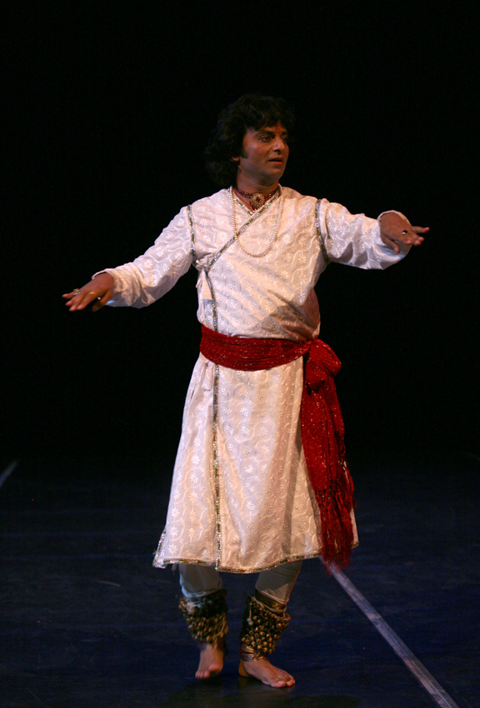
Ravi Shankar Mishra comes from one of the musical families of Benares. From a young age he chose kathak dance, all the while acquiring a complete training as a tabla player. He masters two complimentary disciplines: dance, which he studied under the fiery Alakhnanda Devi followed by Pandit Pandey Maharaj, and tabla, which he studied under Pandit Panchoo Maharaj.

Since childhood, he has participated in numerous performances and has become emblematic of the kathak of Benares. He travels in Europe and has made this dance known through workshops and performances at intercultural meetings with Western artists, notably in the show 'From Benares to Jerez', and then 'Indialucia', where kathak and flamenco interact.

As a dancer as well as a percussionist, he is worthy of representing the Benares gharana, to which belong the reputed percussionists Pandit Kishan Maharaj, Pandit Shamta Prasad, Pandit Sharda Sahaia, Pandit Anokhelal Mishra and Mahapurush Mishra. The Benares style is characterised by a large repertoire of compositions and the efficacy of its rhythms. It has also been influenced by the playing of pakhavaj, a traditional drum associated with the styles of dhrupad and dhammar, as well as the nal or dholki, which are particularly adapted to popular music.

Kanchen Mishra – Harmonium, vocal

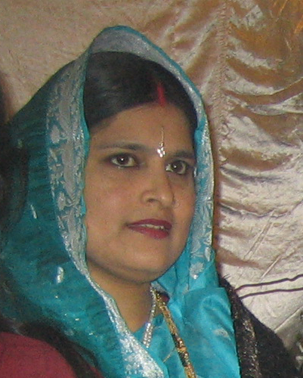
Born in a musical family, she studied music and vocal and obtained her master in Arts at the University in Ranchi. She recorded several pieces for the All India Radio before her marriage with the dancer Ravi Shankar Mishra.

She is accompanying her husband for his kathak classes, and follows her children musical studies, teaching them vocals and the practice of harmonium.

THE YOUNG ARTISTS

Sandeep Mishra - Sarangi
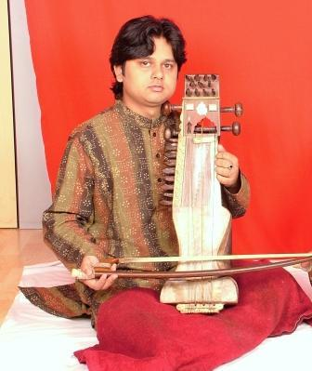
Sandeep Mishra hails from the renowned Sarangi Gharana (school) of Benaras, India. Since his childhood he had a flair for singing and acquired a high level proficiency in vocal singing under the guidance of his guru and grand father the great maestro late. Pandit Narayan Das Mishra. He had a strong inclination and talent in music, and received subsequent training and guidance under his grand father Pandit Bhagwan Das Mishra - the world renowned Sarangi maestro and his father Pandit Santosh Kumar Mishra.

Sandeep has added a new innovation and style to his Sarangi by blending a contemporary approach to this traditional instrument without forsaking its purity. He can play at ease the nuances of the very pure classical Indian form of music and also the contemporary/modern music on Sarangi. He is a versatile performer collaborating with musicians from different genres and styles all over the world and creating new musical language. His performance is well reflected in his achievements in the field of Shastriya Sangeet.

In this short span of his life, Sandeep has made an endeavor to revive the ancient style of this soul-touching instrument, the Sarangi. He has acquired the ‘tantakri’ and ‘gayaki’ style of playing Sarangi from his father and practiced it since his childhood. His unparallel talent allowed his seniors and gurus to call him a child prodigy.
.

Ram Kumar Mishra

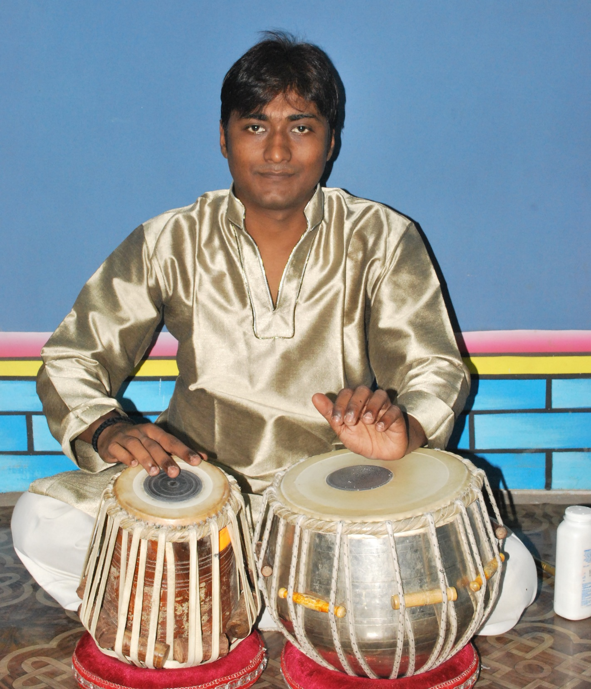
Music running through their veins. Ram Kumar Mishra belong to one of the most respected family of Banaras Gharana tradition. Son of the Tabla Maestro of Banaras Gharana Pt. Shiv Shankar the displayed a flair for Tabla as a tender age.

While their paternal grandfather Late Pt. Nageswar Prasad Mishra was an eminent Tabla player of Banaras Gharana. Early in their formative years themselves. He decided the to pursue Tabla and where initially trained in it by their father and Guru. Under their tutelage, they commenced daily practice of four and five hours.

He have also received advanced training from the inimitable Pt. Ravi Shankar Mishra who is also his uncle.

Saurav and Gaurav Mishra

Saurav and Gaurav Mishra are twins. As the youngest sons of Pandit Armanath Mishra, they belong to a respected family of musicians and have grown up surrounded by artists.

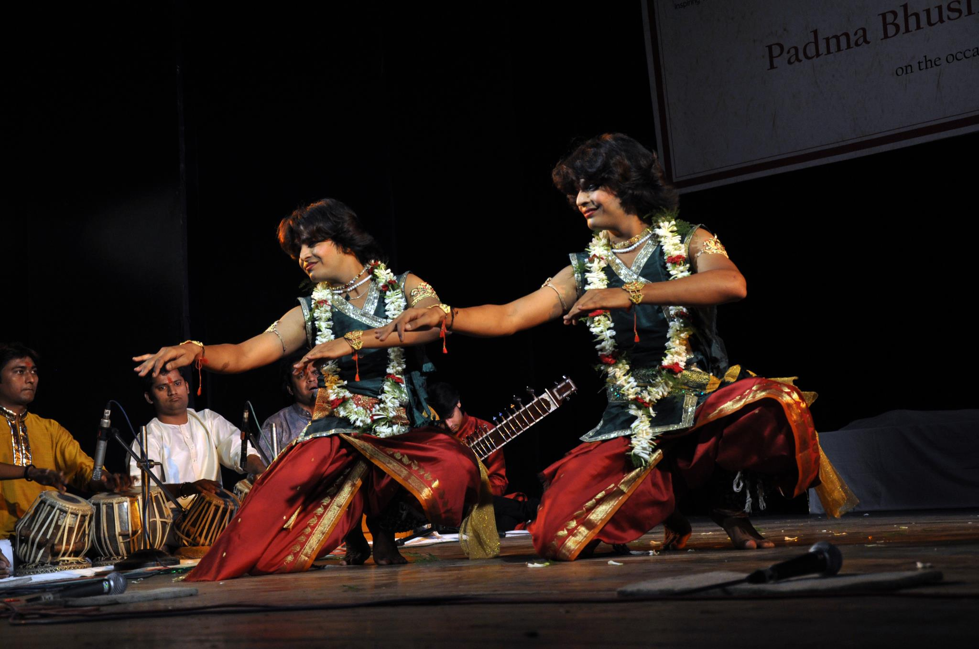
Early in their formative years themselves, they decided to pursue kathak dance and where initially trained in it by their uncles and Gurus Pt. Ravi Shankar Mishra and Pt. Mata Prasad Mishra, the famous kathak dancing duo of Benaras Gharana. Under their tutelage, they commenced daily practice of four to five hours. They have also received advanced training from the inimitable Padma Vibhushan Pt. Birju Maharaj, who is also their maternal uncle, in many workshops.
At the age of 11, they made their first public debut at Sangeet Sabha Kashi, the organisation of Late Padma Vibhushan Pt. Kishan Maharaj, where they received blessing from Pt Birju Maharaj, Pt Rajan and Sajan Mishra, Padma Vibhushan Girija Devi amongst other renowned artists.
Today Saurav and Gaurav maintain a busy performing career alongside their studies in dance and music in Benaras. They have performed at various prestigious festivals in India and mesmerised the audience with their inimitable style and the precision of their rythmic patterns.

Aditya Shankar Mishra et Abhijeet Mishra – tabla and kathak

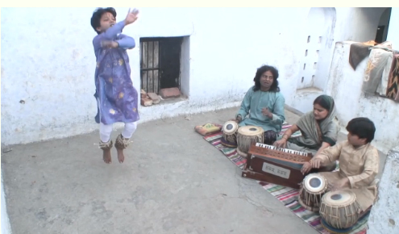
Sons of Ravi Shankar Mishra, Abhijeet (14) and Aditya (12) have grown up in their family house of Kabir Chaura, the clasical musician’s area in Varanasi. Inspired by their father’s practice and guided by their mother’s knowledge, they have choose the study of kathak for the yyounger and the tabla for the elder. Beside their solid studies at school, they are practicing with passion and devotion their art and have reach a high level. The documentary film « Growing into Music » has followed them during 3 years on the way they are taught by their parents.

Fanny « Meera » Marquet

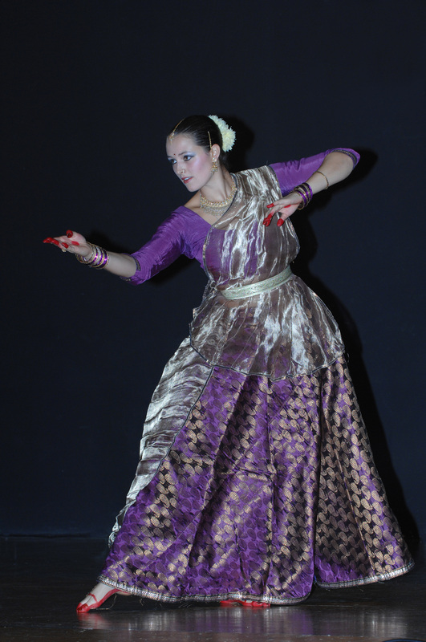
Since the age of 12, Fanny is fond of Kathak dance. For 12 years, she has been learning its subtleties with her dance master (guru) Pt. Ravi Shankar Mishra. She thus developed a surprising grace and ease in the interweaving of complex rhythms and graceful movements of Kathak. Since 2006, she goes regularly to India in Varanasi, where she learn Kathak in the traditional family of musicians and dancers of her Guru. Various stays of 5 to 6 monthes also allowed her to show her capacities on Indian stages.
Since then, she is performing in Switzerland and in France for various festival such as « Poussière du Monde» in Geneva (2008) and the festival of Durga Puja organised by the Indian community of Geneva (2010). She also took part in the projects of the association « CulturAll »: « Geet Govind » (2009) and « Beyond Skin » (2010).

She then came back to India, from September 2011 to March 2012, and in the winter 2012-2013, again in the house of her Guru and performed in the Faculty of Performing Arts in Banaras Hindu University. In January 2013, and in Rashtri Kathak Sansthaan, receving recognition from the local media. Inhabited by the love for dance, Fanny is involved in the promotion of this art by performing on stage as well as by teaching in various schools and wishes to make it more accessible to the European public.

Priscilla Bruelhart - Kathak

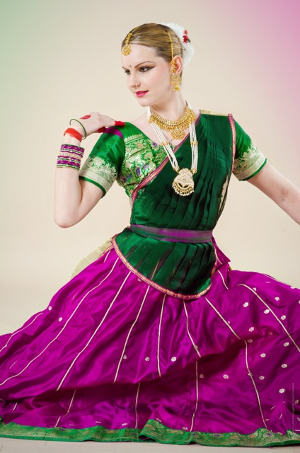
Priscilla started her artistically studies in Monaco at the Music conservatory as well as in the dance school Dance Plus. Later on she also went to Laban Dance Center in London for workshop. At that time she is practicing several dance styles as: Classical, jazz, contemporary, and funky. In year 2006 Priscilla discovered Kathak and is immediately captivated by this rhythmic and charming art of performing art. She specialized herself in this dance style and develops her own creations bringing together the complexity of this classical art with the liberty of modern dance.
Her Kathak Guruji is Pandit Ravi Shankar Mishra from Benares. She is also growing under the guidance of her Guruji Pandit Udai Mazumdar. She is learning from him the complexity of Indian rhythms as well as tabla. During her stays in India she also had the opportunities to work and to learn with different artists from different Gharanas.
Priscilla participates to several international dance workshops all over the world and is touring in different dance projects in Europe as well as in India. Since september 2012, Priscilla joined the compagny Sapana (dream) founded by her Gurubahin Fanny Marquet (Meera) with whom she is training and performing since several years and Anjali Shah.

